IMPLEMENTATION OF LINKED LIST USING LINEAR SEARCH AND BINARY SEARCH USING ADT

AIM:
To implement a Linked List ADT in C and perform Linear Search and Binary Search on the linked list.

PSEUDO CODE:
START
Step 1: Create a node with two fields:
- Data
- Next pointer

Step 2: Initialize head = NULL.

Step 3: Read the number of nodes (n).

Step 4: Repeat n times
a. Read an element.
b. Create a new node.
c. Store the element in the node.
d. If the list is empty,
Make the new node as head.
Else
Move to the last node.
Link the new node at the end.

Step 5: Display the linked list.

Step 6: Read the element to search using Linear Search.

Step 7: Start from the first node.
Compare each node with the search element.
If found,
Display its position.
Else
Move to the next node.
If the end of the list is reached,
Display "Element not found".

Step 8: Read the element to search using Binary Search.

Step 9: Set start = head and last = NULL.

Step 10: Find the middle node using slow and fast pointers.

Step 11: Compare the middle node with the search element.
If equal,
Display "Element found".
Else if search element is greater,
Search the right half.
Else
Search the left half.

Step 12: Repeat Steps 10 and 11 until the element is found or the search ends.

Step 13: If the element is not found,
Display "Element not found".

STOP
PROGRAM :
#include <stdio.h>
#include <stdlib.h>

struct Node
{
int data;
struct Node *next;
};

struct Node *head = NULL;

// Insert at end
void insert(int value)
{
struct Node *newNode = (struct Node *)malloc(sizeof(struct Node));
newNode->data = value;
newNode->next = NULL;

if (head == NULL)
head = newNode;
else
{
struct Node *temp = head;
while (temp->next != NULL)
temp = temp->next;
temp->next = newNode;
}
}

// Display
void display()
{
struct Node *temp = head;
printf("Linked List: ");

while (temp != NULL)
{
printf("%d ", temp->data);
temp = temp->next;
}
printf("\n");
}

// Linear Search
void linearSearch(int key)
{
struct Node *temp = head;
int pos = 1;

while (temp != NULL)
{
if (temp->data == key)
{
printf("Linear Search: Element found at position %d\n", pos);
return;
}
temp = temp->next;
pos++;
}
printf("Linear Search: Element not found\n");
}

// Find Middle
struct Node *middle(struct Node *start, struct Node *last)
{
if (start == NULL)
return NULL;

struct Node *slow = start;
struct Node *fast = start->next;

while (fast != last)
{
fast = fast->next;
if (fast != last)
{
slow = slow->next;
fast = fast->next;
}
}
return slow;
}

// Binary Search
void binarySearch(int key)
{
struct Node *start = head;
struct Node *last = NULL;

do
{
struct Node *mid = middle(start, last);

if (mid == NULL)
break;

if (mid->data == key)
{
printf("Binary Search: Element found\n");
return;
}
else if (mid->data < key)
start = mid->next;
else
last = mid;

} while (last != start);

printf("Binary Search: Element not found\n");
}

int main()
{
int n, value, key;

printf("Enter number of nodes: ");
scanf("%d", &n);

printf("Enter %d elements (in sorted order):\n", n);

for (int i = 0; i < n; i++)
{
scanf("%d", &value);
insert(value);
}

display();

printf("Enter element to search using Linear Search: ");
scanf("%d", &key);
linearSearch(key);

printf("Enter element to search using Binary Search: ");
scanf("%d", &key);
binarySearch(key);

return 0;
}
OUTPUT :

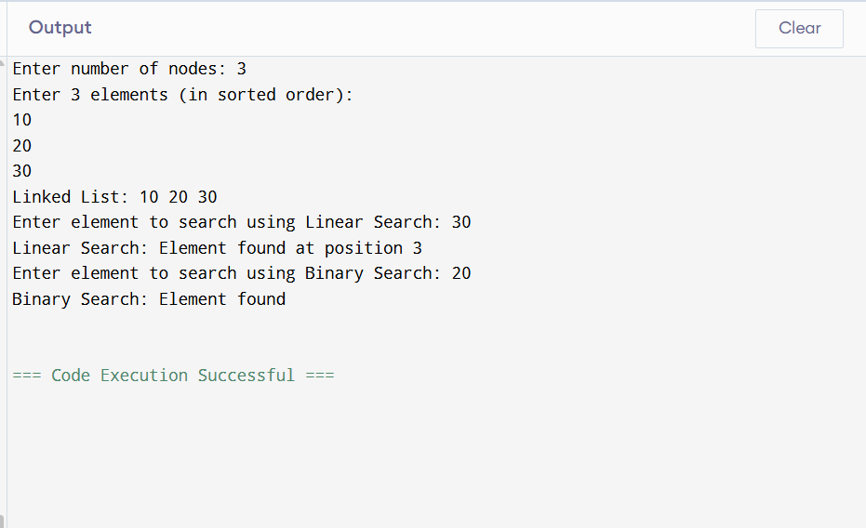

RESULT :
Thus, the Linked List ADT was implemented successfully, and the required element was searched using Linear Search and Binary Search in C.

